Challenges and Limitations of Maximum Likelihood Estimation (MLE) in Speech Data Analysis

## Objective: Utilizing Maximum Likelihood Estimation (MLE) for Parameter Estimation in Speech Data Analysis

The objective is to calculate the coefficients αij and Aij for each pair of Ri and Sj by fitting all available data into a linear equation of the form FRi = αijFSj + Aij(αij − 1) using linear regression techniques. This approach incorporates MLE principles to optimize parameter estimation, particularly in scenarios involving missing values. The analysis will be conducted using the Peterson-Barney and Hillenbrand vowel datasets, aiming to enhance our understanding of speech characteristics and improve modeling accuracy.

## Motivation Behind Linear Regression Approach for Comparing Formant Frequencies in Speech Analysis

We're using this equation for linear regression to find a simple way to compare formant frequencies between speakers. The equation is designed to easily show differences between genders: when speakers have similar genders, a value close to 1 for αij indicates a strong correlation in their formant frequencies. But if they have different genders, αij will be farther from 1, helping us identify distinct speech patterns. The Aij term adds more detail, capturing variations beyond gender. By applying this equation with linear regression, we aim to better understand how speakers' formant frequencies relate and improve our methods for analyzing speech.

Hillenbrand Speech Data

Data Pre Processing:

Adding Columns to ID by Sex

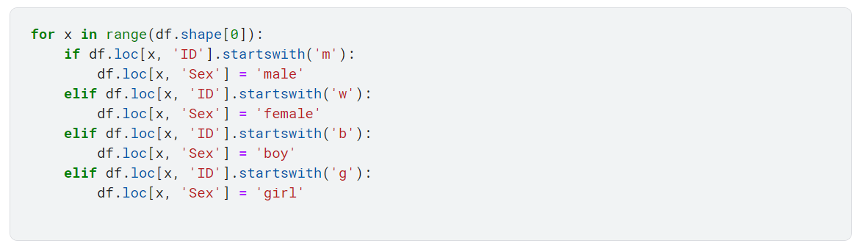

And similar thing is done for vowels.

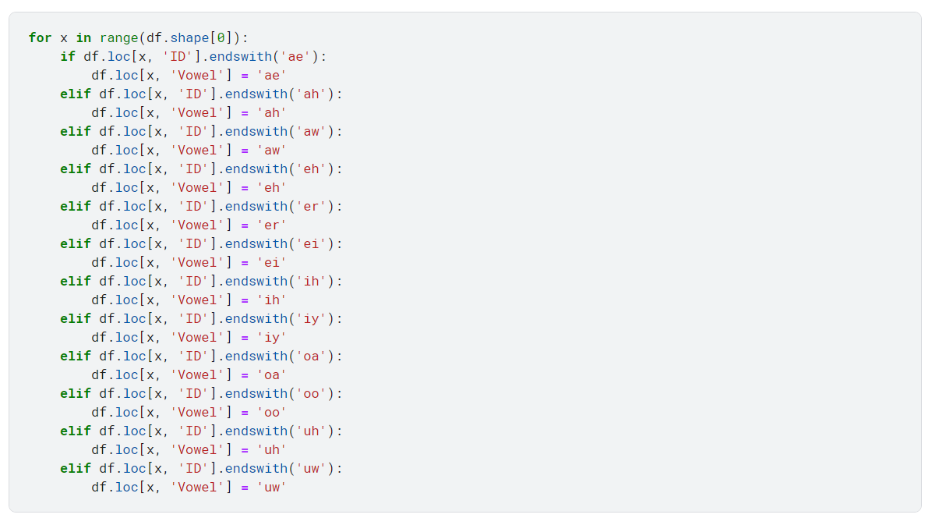

Each row in our dataset corresponds to an individual's vowel speech data, containing information such as duration and formant frequencies at various percentiles. The ID for each entry follows a specific format: it begins with the individual's gender, followed by a gender-specific ID, and ends with the vowel identifier. To facilitate analysis, we are parsing the ID format and separating its components into distinct columns. This segmentation allows us to organize the data efficiently, enabling further exploration and interpretation.

Handling Missing Values:

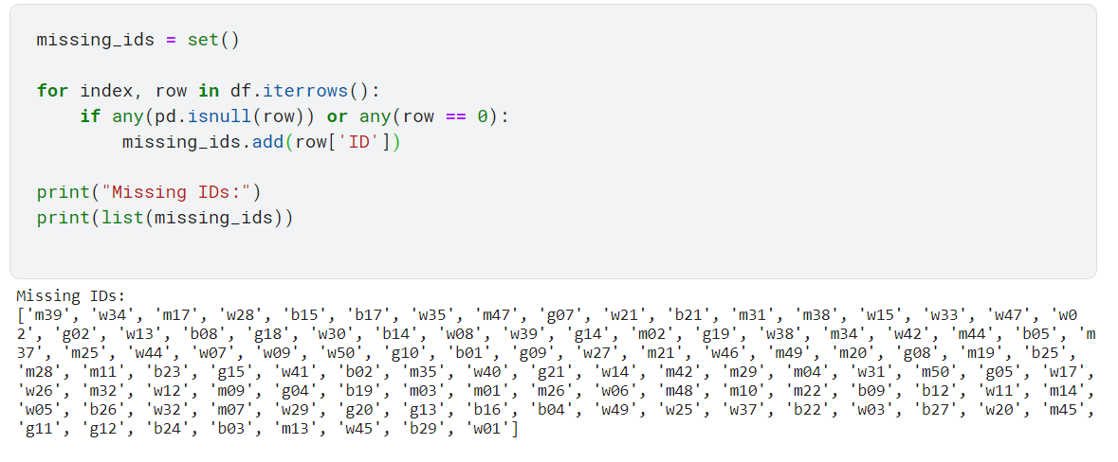

We've noticed a notable pattern: approximately 93 rows contain at least one missing value. This observation holds significant weight in our analysis, as discarding the data from these 93 individuals would lead to a substantial loss of valuable information. Hence, it becomes imperative to address the issue of missing values in a thoughtful manner, ensuring that we retain as much data as possible for meaningful insights and accurate modeling.

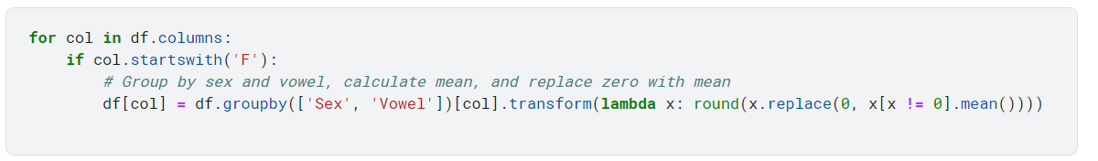

In this section of the code, any missing values encountered are addressed through imputation. Specifically, if a missing value is detected, it is replaced with the average formant frequency value corresponding to the same sex and vowel category. Notably, data points with a value of 0 are excluded from this calculation to ensure accuracy in the imputation process. This approach aims to maintain the integrity of the dataset by substituting missing values with contextually relevant estimates derived from similar instances within the dataset.

Data Modification and MLE Calculation:

Segregating frequency column names into a list and Concatenating Speaker Data into Single Arrays for Linear Regression



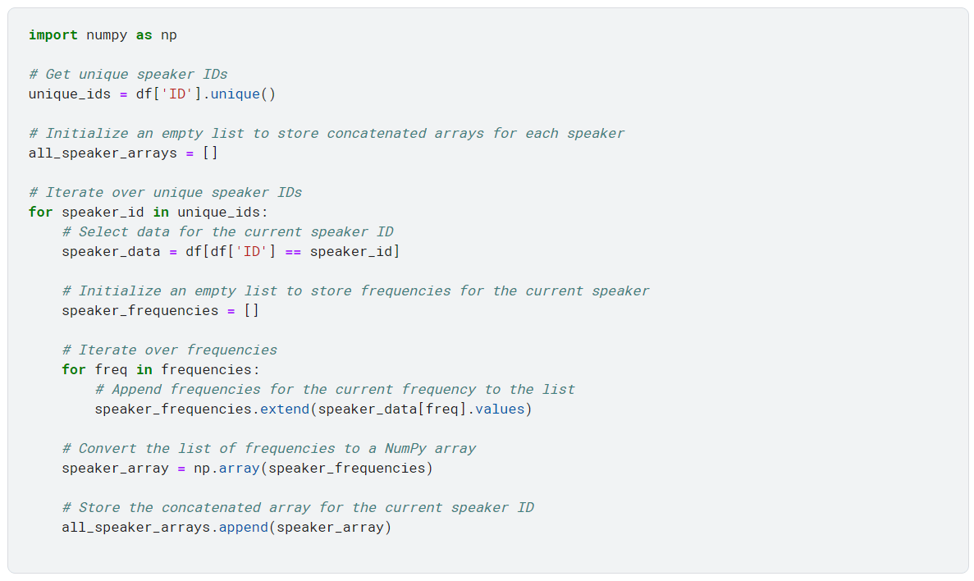

Using the linear regression module, we aim to fit the data of each pair of speakers into a linear equation.

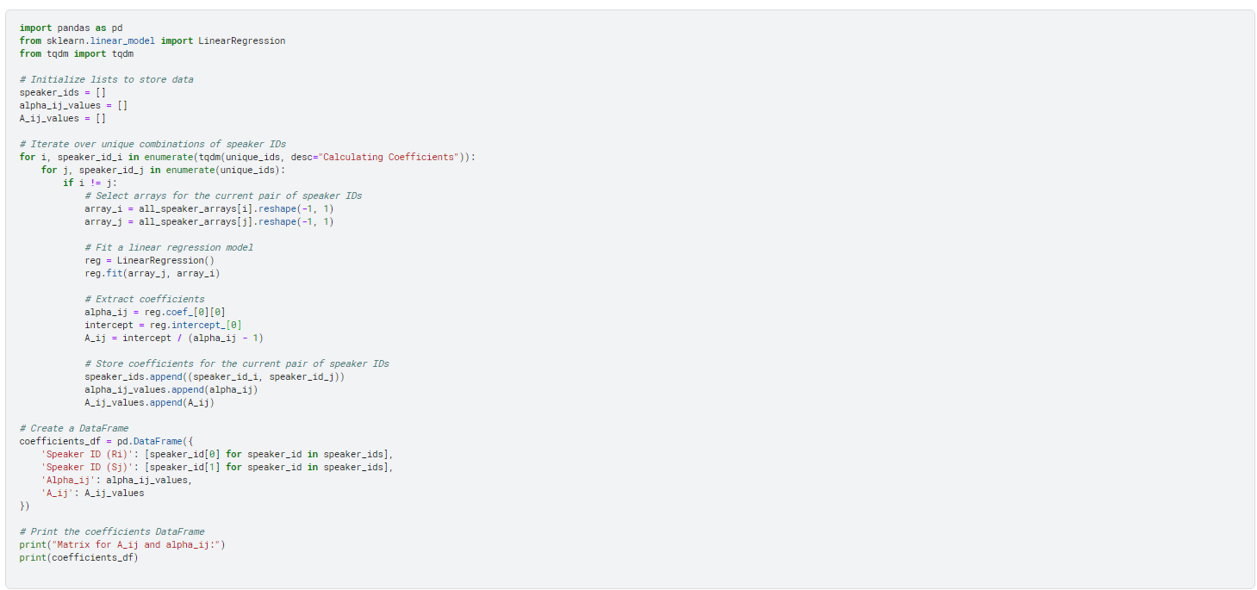

We fitted the data of each pair of speakers into the linear equation FRi = αijFSj + Aij(αij − 1). Observations reveal that the value of Aij tends to exhibit larger positive or negative values when comparing male speakers to male speakers, as well as when comparing female speakers to female speakers, compared to comparisons between male and female speakers.

We're segregating data for each speaker who has a higher absolute value of Aij compared to the other speaker, and then keeping them in a new data frame. Specifically, we're considering values of Aij with a magnitude greater than 1000 as a reference for higher values.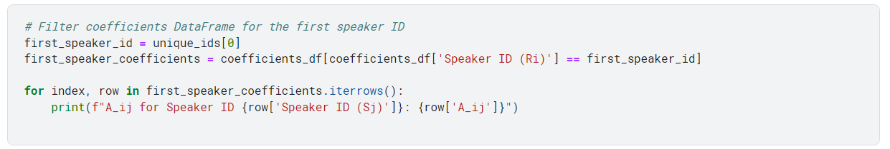

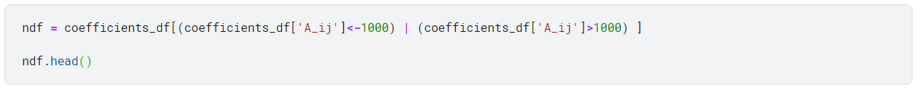

We're creating a data frame to display, for each speaker, the count of male and female speakers with an absolute Aij value greater than 1000.

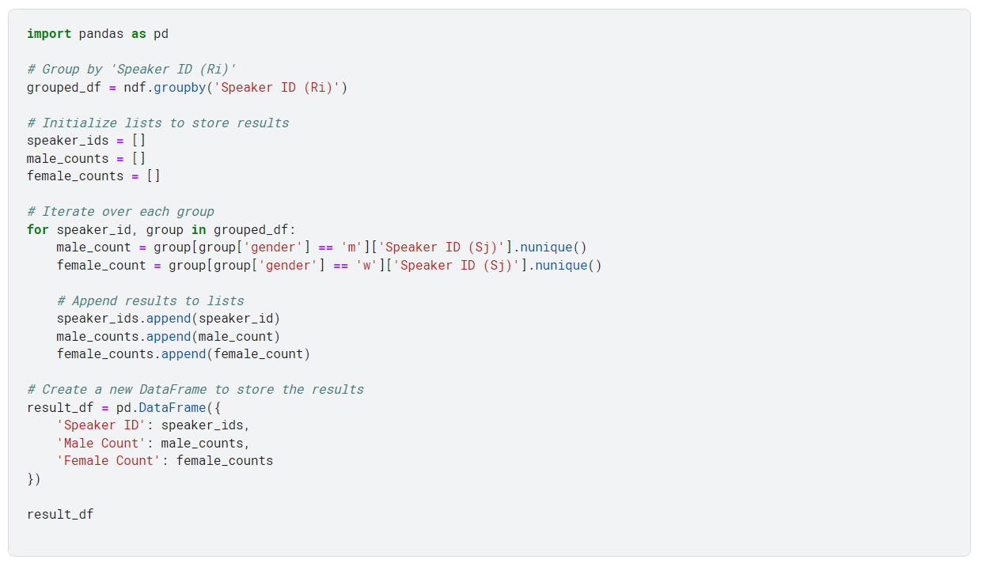

Calculating average male and female count for each gender with Aij having an extreme value

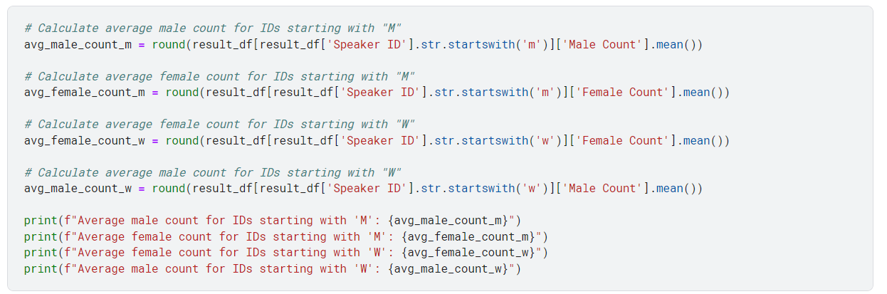

Average male count for IDs starting with 'M': 18

Average female count for IDs starting with 'M': 2

Average female count for IDs starting with 'W': 23

Average male count for IDs starting with 'W': 6

It's evident from the data that there's a substantial difference in the average counts between same-gender pairs and opposite-gender pairs with higher values of Aij. Specifically, there's a notably higher average count of individuals of the same gender compared to the opposite gender in the category of speakers with higher Aij values.

Peterson & Barney Speech Data

###### **For the Peterson-Barney dataset, the overall process remains largely unchanged from the previous dataset (Hillenbrand). However, there are notable differences:**

###### **No Missing Values: Unlike the Hillenbrand vowel speech data, the Peterson-Barney dataset doesn't contain any missing values. Therefore, there's no need for additional handling of missing data.**

###### **No Formant Frequencies at Percentiles: In contrast to the Hillenbrand data, the Peterson-Barney dataset doesn't include columns for formant frequencies at different percentiles. Only the formant frequencies themselves are provided.**

###### **Exclusion of Duration Data: Duration data is not considered in the Peterson-Barney dataset.**

###### **Despite these differences, the overall procedure for processing and analyzing the Peterson-Barney vowel speech data remains largely the same as outlined previously for the Hillenbrand dataset.**

Average male count for IDs starting with 'M': 13

Average female count for IDs starting with 'M': 2

Average female count for IDs starting with 'W': 11

Average male count for IDs starting with 'W': 5

The data from the Peterson-Barney dataset supports the conclusions drawn from the Hillenbrand dataset.

Similar to the Hillenbrand dataset, we observe a significantly higher count of individuals of the same gender compared to the opposite gender in the category of speakers with higher Aij values.

**Data Source: The data for the Peterson-Barney and Hillenbrand vowel datasets is sourced from the GitHub repository you provided.**